Test Case: tc001_SPX_Dev5_Crear_Solicitud_Articulo_Almacen
Step 1 - Enter username and password and click to button Enter : Credentials Entered
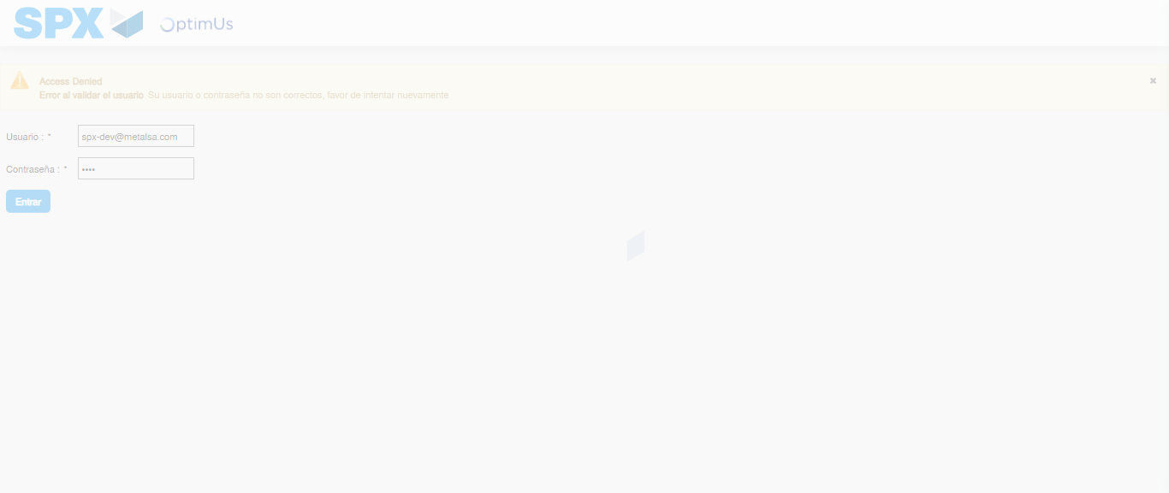Image file-name: QC_Testing-tc001_SPX_Dev5_Crear_Solicitud_Articulo_Almacen-1788279962853

Step 2 - Select to UEN and Access to Request for a New Inventory Item : UEN Correctly selected and Correct access
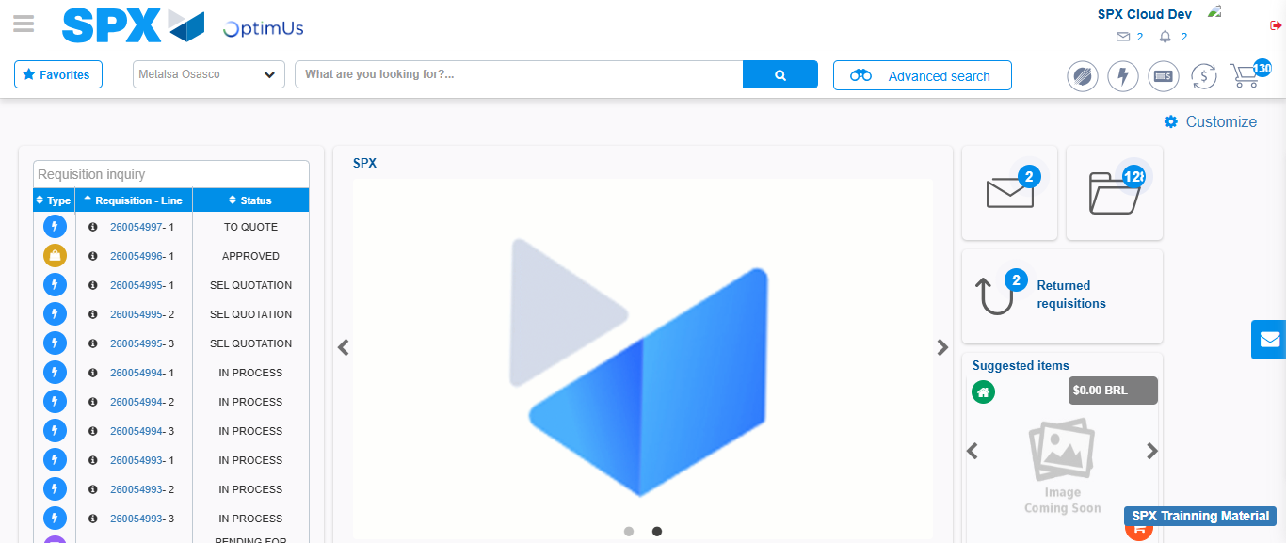Image file-name: QC_Testing-tc001_SPX_Dev5_Crear_Solicitud_Articulo_Almacen-1788279989652

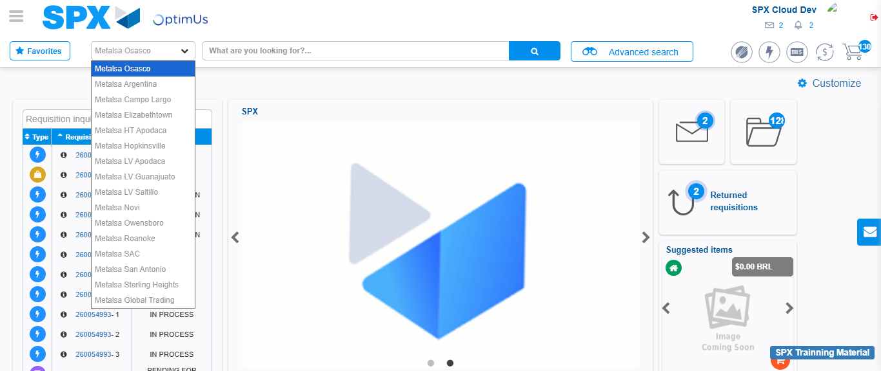Image file-name: QC_Testing-tc001_SPX_Dev5_Crear_Solicitud_Articulo_Almacen-1788279990321

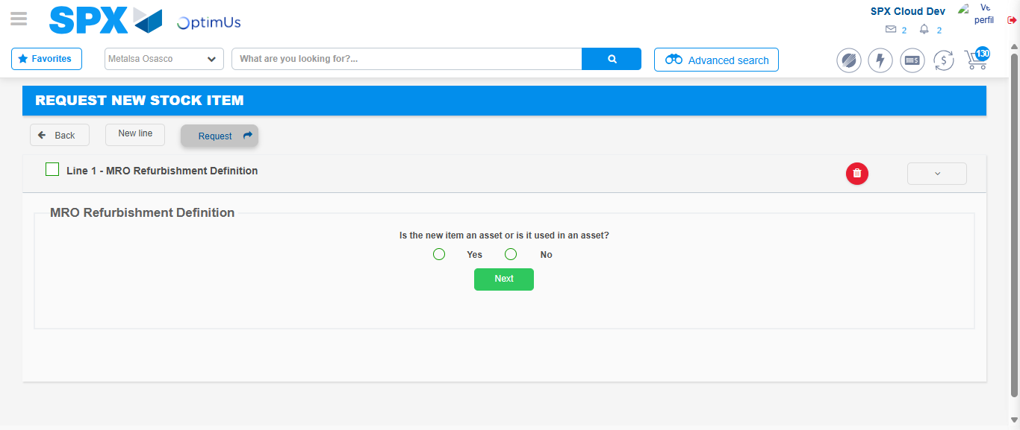Image file-name: QC_Testing-tc001_SPX_Dev5_Crear_Solicitud_Articulo_Almacen-1788280012076

Step 3 - Select options first section : Options seleted correctly
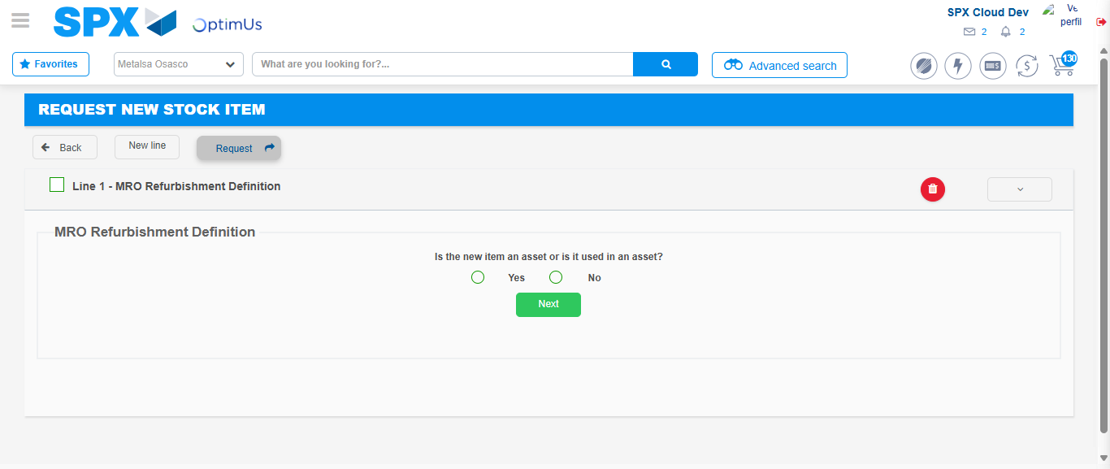Image file-name: QC_Testing-tc001_SPX_Dev5_Crear_Solicitud_Articulo_Almacen-1788280012430

Image file-name: QC_Testing-tc001_SPX_Dev5_Crear_Solicitud_Articulo_Almacen-1788280012656

Step 4 - Select options at Screen: Options seleted correctly
Image file-name: QC_Testing-tc001_SPX_Dev5_Crear_Solicitud_Articulo_Almacen-1788280012430

Image file-name: QC_Testing-tc001_SPX_Dev5_Crear_Solicitud_Articulo_Almacen-1788280012656

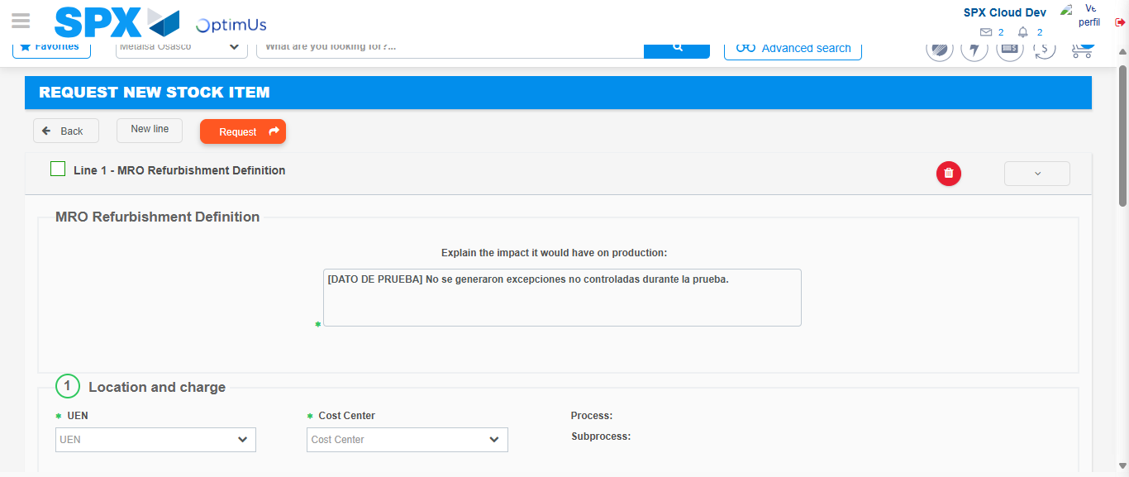Image file-name: QC_Testing-tc001_SPX_Dev5_Crear_Solicitud_Articulo_Almacen-1788280023025

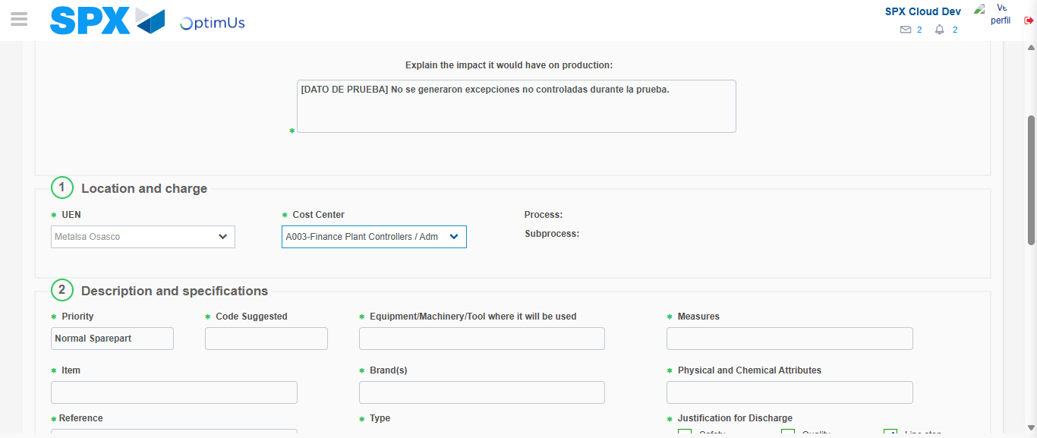Image file-name: QC_Testing-tc001_SPX_Dev5_Crear_Solicitud_Articulo_Almacen-1788280025817

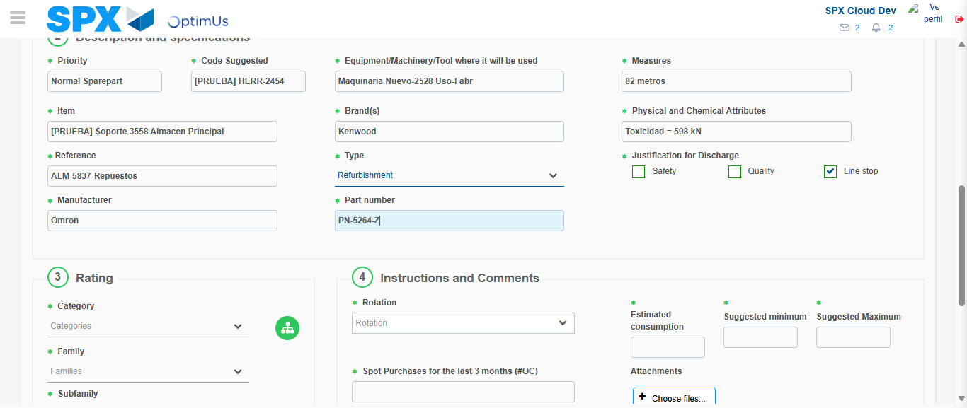Image file-name: QC_Testing-tc001_SPX_Dev5_Crear_Solicitud_Articulo_Almacen-1788280027645

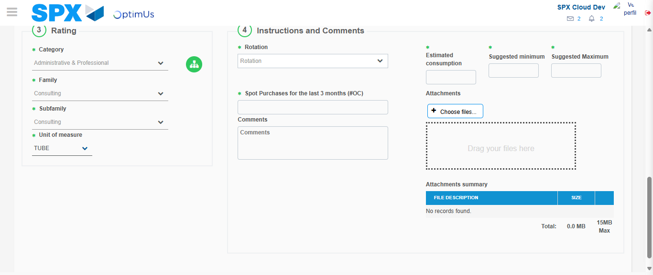Image file-name: QC_Testing-tc001_SPX_Dev5_Crear_Solicitud_Articulo_Almacen-1788280032296

Step 5 - Request New Item : Request Accepted
Image file-name: QC_Testing-tc001_SPX_Dev5_Crear_Solicitud_Articulo_Almacen-1788279989652

Image file-name: QC_Testing-tc001_SPX_Dev5_Crear_Solicitud_Articulo_Almacen-1788279990321

Image file-name: QC_Testing-tc001_SPX_Dev5_Crear_Solicitud_Articulo_Almacen-1788280012076

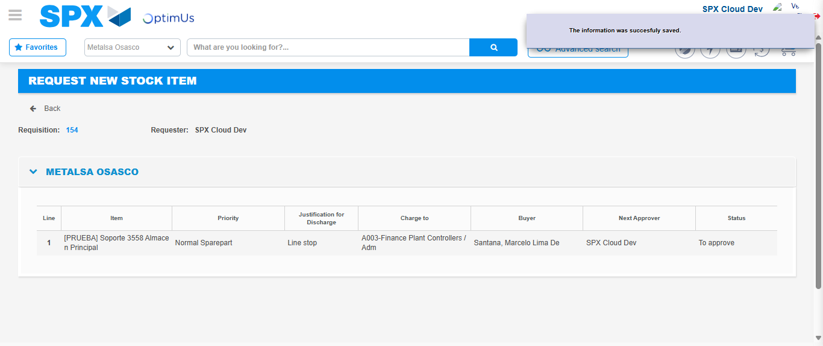Image file-name: QC_Testing-tc001_SPX_Dev5_Crear_Solicitud_Articulo_Almacen-1788280039557

Image file-name: QC_Testing-tc001_SPX_Dev5_Crear_Solicitud_Articulo_Almacen-1788280039785

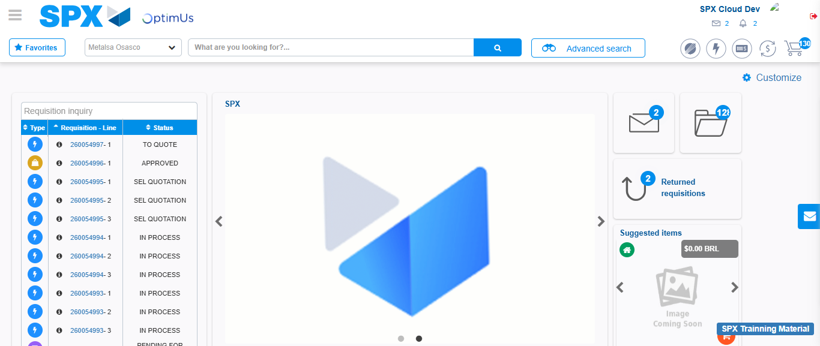Image file-name: QC_Testing-tc001_SPX_Dev5_Crear_Solicitud_Articulo_Almacen-1788280061099

Step 7 - Return to Main Page SPX : Return to Main Page SPX
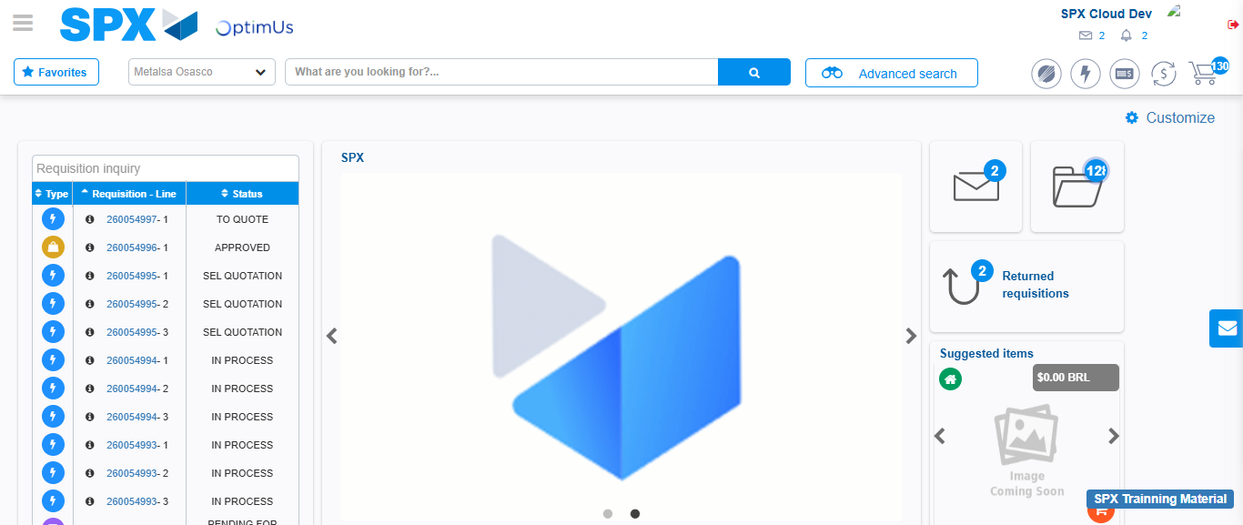Image file-name: QC_Testing-tc001_SPX_Dev5_Crear_Solicitud_Articulo_Almacen-1788280061413

